James Zartman

METC-111

Dale DeRoche

12/2/2018

**M939 Platform Project**

**Problem:** I was asked to figure out the size of the cables needed to hold the platform that was being designed as well as the M939. I was given that there would be four 25 foot cables attached at each corner of the platform. I had to then take the specifications of the M939 along with the specifications of the platform to figure out the loading that these four 25 foot cables would see. This all needed to be done in a timely matter as to not hold up the bid process.

**Given:** The platform will be lifted by a 25' cable that splits into 4 individual cables that attach at each corner of the platform. The platform is assumed to be the L*W of the vehicle, plus 20% of the H in all directions. The single supporting cable makes its split into 4 cables at 200% of H above the platform.

Cable length: 25 feet (4)

Length of truck (L): 307.4 Inches

Width of truck (W): 97.5 Inches

Height of truck (H): 115 Inches

Curb weight of truck: 21,470 pounds

**Solution:** How I reached my solution with my calculations

1. Using the specifications provided and knowing that the platform had to be 20% bigger on all sides. I figured out the length and width of the platform that was going to be used.

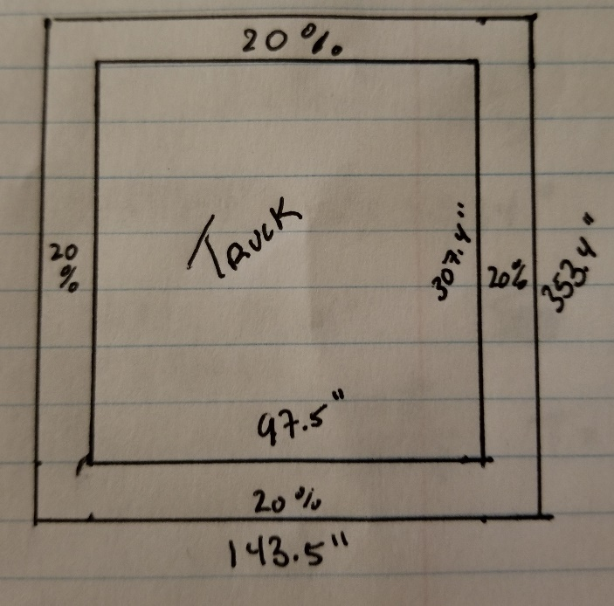

1. Using the information about the platform I drew out the platform to set up the geometry to be able to determine the angle the cables would make with the platform

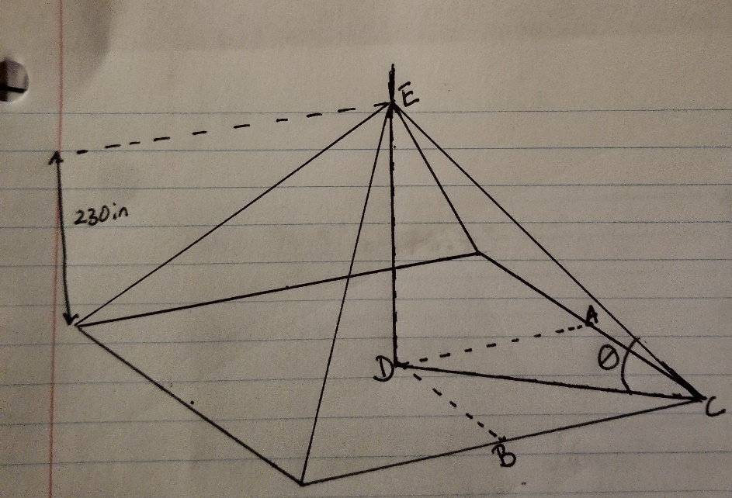

1. I divided the curb weight by four because the load would be evenly dispersed into all 4 cables since it was supporting the platform from each corner. I also found the height where the main cable splits into 4.

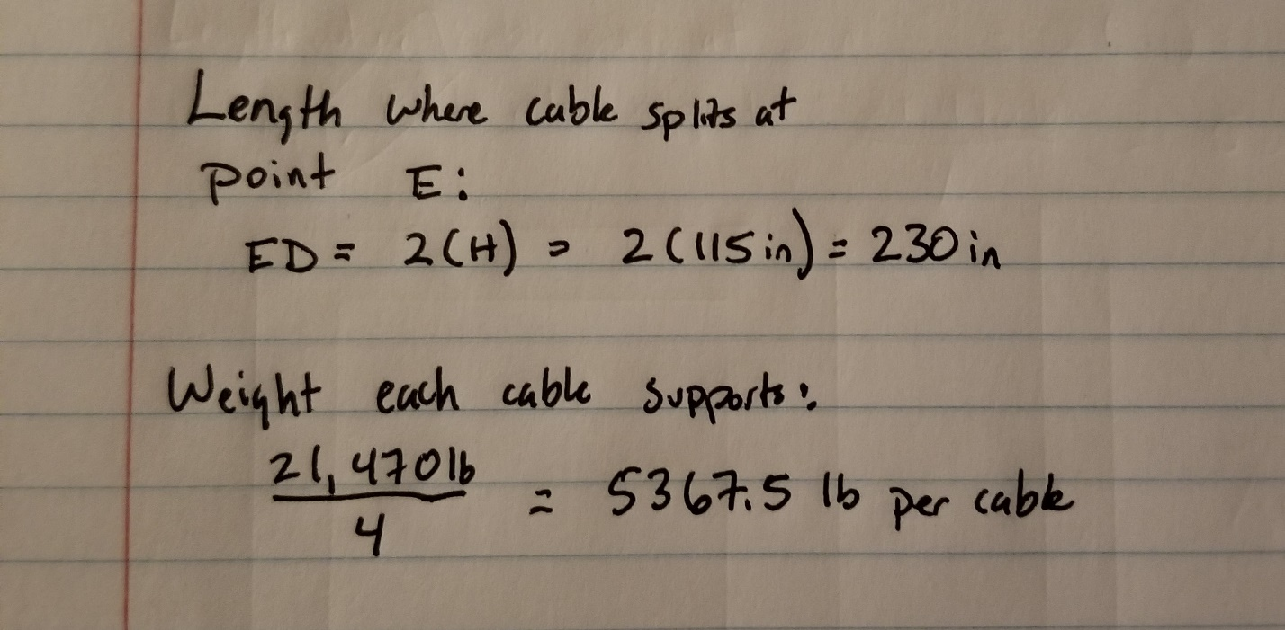

1. I used the Pythagorean theory to find the angles at which the cable supports the platform

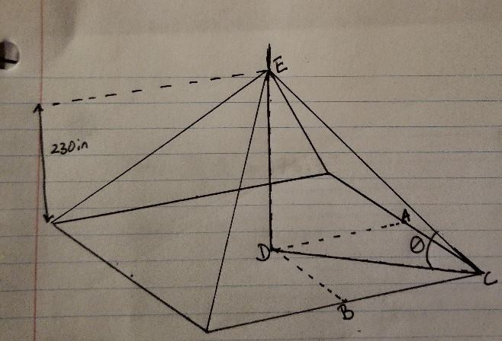 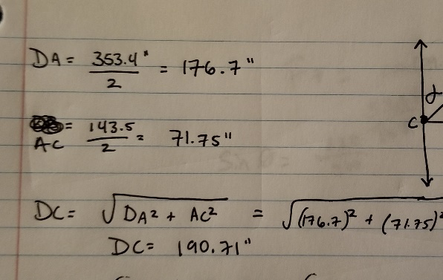

1. From there I used trigonometry to find the loading for one cable then found that was the same weight for each cable since they all support the weight evenly.

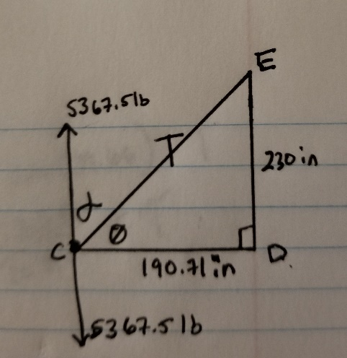 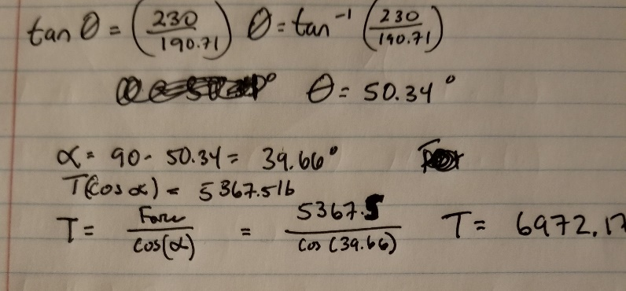

1. I discovered that the loading of each cable was **6972.17 lb per cable.**

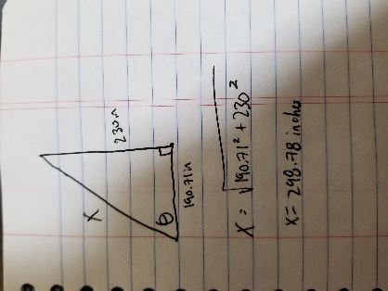

1. From here, I then used the Pythagorean Theorem to figure out the length of the cable. Found that the cables need to be **298.78 inches**